Guidance and application form

An opportunity for education and training sector providers across the North West and Yorkshire & Humber areas to transform teaching, Learning and assessment.

The Learning Consortium has secured funding from the Education and Training Foundation for practitioners to undertake collaborative development to transform Teaching, Learning and Assessment (TLA). This is an invitation for education and training sector providers in these regions to bid for practitioner-led projects which support learners by improving TLA. The overall aim for these funds is for practitioners to improve TLA through projects where groups of practitioners from across the range of providers (including ITPs, ACL, OLASS, third sector or FE Colleges) work together collaboratively to investigate and develop TLA approaches for the benefit of learners.

SFA funded providers are invited to apply for a TLA collaborative development project worth up to a total of £25k, including up to £15k for the release of staff time, with a focus on learner outcomes through improved learning and classroom practice, informed by research.

Providers with any inspection grade are invited to apply: what’s key is to show how you plan to impact on learners through improved professional practice. Project collaborations should involve groups of eligible providers, and applications which involve collaborative working between different provider types are welcome. We also welcome applications which involve third sector or OLASS providers.

If you are interested in applying please read the following guidance and return the completed application form by email to the contact below. Please note late applications cannot be considered.

Learning contact details and deadline for applications

EMAIL:learningconsortiumenquiries@gmail.com DEADLINE: midnight 16 December 2016

- Working together to improve TLA and potential areas for the Practitioners Development Fund
Our approach calls for groups of practitioners from different organisations who want to work together, with peer support provided from members of The Learning Consortium.

You may apply with an existing or new partnership grouping, or make a solo application and ask us to try and identify regional partners who are interested in the same TLA areas (we will then try our best to match you to a suitable grouping - though obviously this cannot be guaranteed).

We will provide:
- mentoring, CPD, training, and other support from Learning Consortium peers,
- training for project participants on project methodology and an introduction to the Professional Standards for teachers and trainers,
- a dedicated “Pass-it-on” project website to log progress, facilitate communication between project members and publicise and disseminate findings, to the sector,
- grants for the release of staff time,
- funding for dissemination activity.
Potential areas for investigation include any aspect of TLA and could include:

• Improvements in TLA practice
• Effective use of data
• Learner Tracking
• Study-Programmes
• Lesson Observation
• TLA quality in apprenticeships
• Embedding/delivery English and maths
• Meeting individual learner needs (online and in the classroom)
1.1 Why Collaborative Development?
The Learning Consortium has been commissioned to contribute to sustainable improvement of TLA in the education and training sector which is underpinned by a solid research base. In particular, it has been tasked with improving the quality of education and training across the whole range of provider types and engaging them in activities aimed at transforming practice. Therefore we may have to prioritise or reject bids to take into account regional spread and equity across provider types.

We are inviting applications from groups of provider organisations for TLA development projects designed around an evidence-based collaborative development model where groups of practitioners meet and collaborate over a reasonable time period. It is intended they work collectively to investigate TLA issues faced in ongoing practice that address practitioners’ regional and local priorities.

These projects are sponsored by the Education and Training Foundation who are committed to outstanding TLA. The opportunities are intended to give practitioners the time and space to reflect, experiment, apply, and also generate their own evidence, in order to improve their own and colleagues’ practice, and produce improved outcomes for learners.
It is generally agreed that relevant and robust research is critical to continuous improvement in our sector. We are adopting a project methodology that relies heavily on research informed professional development, with a planning process supported by Consortium peers to ensure the highest possibility of success for activities with learners.
The aspiration is that, by the use of research and the Professional Standards, evidence based practice and innovation will be recognized as fundamental to the professional identity of those who work in the education and training sector. How you intend to evidence and measure learner progress will be critical.
The outcomes of previous projects which have investigated similar areas will also be important. To see case studies from The Learning Consortium, and reports and outcomes of previous similar projects run by the Education and Training Foundation in other regions of England, visit their website: http://improving-teaching.excellencegateway.org.uk/
The overview of the project methodology is shown overleaf. Please consider this carefully, and the eligibility criteria, when creating your proposal.

1.2 Methodology
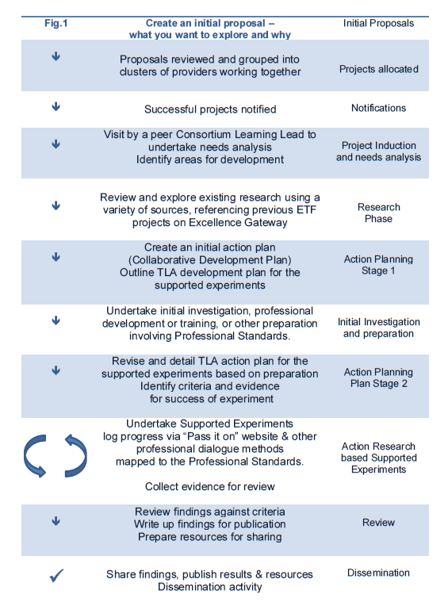

Key dates and timeline  Deadline for applications received | Midnight 16th December 2016
Successful projects notified | 6th January 2017
Projects start | 8th January 2017
Interim Report  Dissemination activity starts | 13th April 2017  1st June 2017
Final Report | 14th July 2017
- Reporting and requirements for all projects

Projects will be expected to provide regular update reports and log progress on a dedicated website. Project participants may also be asked to supply information relating to learner progress, staff attendance or dissemination at training events or meetings as well as equal opportunities monitoring data and surveys for the Education and Training Foundation.

All projects will be required to run dissemination activities to share the findings from the project. Funding will be available for these. The types of activity may include: webinars, learning walks or learning raids, open days or networking events.

On completion, all projects will produce a case study report together with outputs and resources that may be of use to other providers. These may be materials that would help others to address the same issue. Examples of suitable outputs for sharing are:
- Teaching and Learning resources
- CPD materials
- Video material
- An investigative paper which explores solutions to particular issues
- Reports on any intervention trialled, outcomes, or a review of the changes made as a result and why

Once the project is complete, providers will be required to upload the outputs to the Consortium Project Website by 30 June 2016.

- Key success factors

Successful projects are likely to demonstrate the following factors:
- The project is focused on research informed improvements in Teaching, Learning and Assessment which can be evidenced and measured
- The application clearly demonstrates it is practitioner-led and supported by a senior manager in the organisations involved
- The project enables collaboration between organisations and additional professional development opportunities that would not otherwise take place
- Funds should be used for the release of staff time, supporting professional development and supporting peer activities

- Eligibility

These projects are for providers who receive Skills Funding Agency funding. The funds are for development purposes and can be used flexibly, for example for the release of staff time, meetings and travel costs. The purchase of capital items is not permitted. All staff participating in the project must be employed by a provider and the application must be supported by a senior manager in the organisation.
The overall aim of these funds is to overcome barriers and provide additional opportunities for development and collaborative activity in circumstances where otherwise it would not take place and include opportunities for reflection. All projects must agree to running dissemination activity and supplying progress reports and relevant improvement data.

Eligible providers may submit up to two different applications for this funding stream but only one application may be funded per lead organisation. Please note that we want to ensure that funding reaches as many providers and provider types as possible.

- What funding can be used for
We are inviting organisations to submit applications for collaborative improvement projects. Funding should be used for release of staff time and professional development, designed around a collaborative model where practitioners from a number of providers work together on their TLA topic(s) of interest.

Successful applicants will receive:
- A package of between 10-15 days of peer support from members of The Learning Consortium, which will involve mentoring and other forms of peer support from a menu of services.
- £15,000 for release of staff time, professional development or research time, meeting costs, travel and subsistence
- £ 2,500 for dissemination activity such as local sharing events, webinars and learning walks.

Your application should reference any support that you will engage for the project, but please note that it is not intended that these funds are used to engage consultants. All funds should be committed within the project schedule, but projects may continue beyond this if funded using your own resources.

Upon approval, a grant award email will be issued confirming the conditions for this fund. Projects must be completed, and outputs loaded onto the Learning Consortium “Pass it on” site which will be open for submission up to 30 June 2016. As the application form will be used as a basis for the grant contract, all forms must be countersigned by a senior manager from the organisation.

- How to apply
The application process is simple and can be completed using the attached template. Note that we are not asking for a detailed action plan at this stage as the project mentors will work with the successful applicants to help develop this.

All applications will be judged on their merits by a selection process which will take into account:

- that the provider is eligible and in the geographical area we cover
- all proposal details have been completed
- consistency with the key success factors listed
- clear and measurable outcomes and a realistic approach to demonstrable improvements (e.g. SMART targets)
- an outline showing the breakdown of the budget to give an indication of how it intended to be spent across the different organisations
- how the project will achieve and measure learner improvement through a specific intervention involving collaborative development between practitioners in different provider organisations
- the proposed dissemination activities
- any innovative aspects of the project.
Annex A: Application Form – Teaching, Learning and Assessment Practitioner Development Fund

 | LEAD APPLICANT  ORGANISATION NAME  UKPRN: http://www.ukrlp.co.uk/ | ……………………………………………………………………..  & UKPRN no. ______________________________  from UK Register of Learning Providers
 | TYPE OF SFA FUNDED ORGANISATION  (please indicate type and confirm SFA funding)  Note only organisations that are SFA funded may apply (see guidance) and beneficiaries must be supporting SFA provision. In the event of any query we reserve the right to make the final decision. By submitting this application you are agreeing to these conditions. | ❑ FE College   Independent Training Provider   Community Learning Provider   Third Sector   Independent Specialist College   Offender Learning   Other * * If Other, tick to confirm you are SFA funded 
 |  | Region: _______________________________
Funding amount requested ** £
** Please attach an indicative breakdown of costs per provider **
1. PROJECT TITLE:

2. PROJECT SUMMARY (max 50 words):

3. Teaching, Learning and Assessment theme addressed:

4. What are the aims and intended outcomes of this project?
Please tell us what changes you hope to achieve as a result of your project and how will these be measured.

5. What are the main activities that you intend to carry out as part of this project?
And please indicate anticipated timing of activities

6. Who are the other provider organisations you intend to work with?
Please list what other providers are involved and how you intend to work with them.
(or PLEASE STATE if this is a solo application seeking to join a partnership)

7. What are the expected impacts and benefits of the project for teachers, trainers and learners?
Please tell us why this project has potential for improvement in TLA practice or learner performance.

CONTACTS FOR BID: Please include name, role within organisation and email/phone contact details.
Name of senior manager endorsing the project:  Role:  Email/phone: |  |  | Application submitted by:  Role:  Email/phone:

