Greater Manchester Search and Apply
UCAS Progress

Good Practice for post-16 providers

Contents

Section 1

Introduction and background

Section 2

Enhancing your Provider Profile

Section 3

Uploading Excellent Course Information

Section 4

Handling Apprenticeship Expressions of Interest

Introduction:

This guide has been produced by the Greater Manchester Learning Provider Network (GMLPN) to support post-16 providers in their use of the UCAS Progress system. The aims are to:

- improve the breadth and quality of the information easily visible to young people, schools and advisers
- encourage more post 16 providers to accept applications via UCAS Progress
- to support the introduction of minimum expectations for handling expression of interest for Apprenticeship opportunities submitted by young people

Background

The Greater Manchester Apprenticeship Hub has been at the forefront of a major initiative to embed the UCAS Search and Apply Process. This is an important step in supporting the Greater Manchester Raising of the Participation Age (RPA) Strategy by:
- Improving the breadth, depth and accessibility of information available to young people and parents.
- Enabling young people to see all that is on offer post 16.
- Positioning Apprenticeships alongside other progression opportunities.
- Developing a more standardised approach for young people to submit applications.
- Helping Local Authorities manage both RPA and tracking of young people’s destinations at 16.

Objectives

Our objectives for the project are to:

- Ensure that the totality of post 16 opportunities which are available to young people post 16 in Greater Manchester are made visible via a single portal to all young people, parents, teachers and colleagues delivering careers information, advice and guidance services
- Present the opportunities in an easily accessible clear and easy to understand format
- Capture and present the full range of Apprenticeship opportunities which are available across Greater Manchester. A key aspect of this guide is to improve the handling of expressions of interest (EOIs) submitted by young people
- Secure the active participation of post 16 providers in utilising the system to process applications and to record when young people are enrolled thereby supporting the tracking of year 11 destinations
- Help providers to take advantage of the new contractual requirement to list all of their post 16 provision on the National Course Directory

Improving Careers Education:

The rationale for developing a search and apply post-16 application process for young people in Greater Manchester is in direct response to concerns raised about the quality and effectiveness of careers guidance provision in schools and the limited access many young people have to appropriate and relevant information on Apprenticeships.
In their review of careers guidance provision in schools, published in September 2013, Ofsted reported that the quality of provision was generally considered to be poor, with only one in five schools delivering provision that ensured their pupils were in receipt of an appropriate and effective level of careers information, advice and guidance (IAG). According to the report, very few schools promoted vocational training and Apprenticeships effectively.

In addition, mainstream platforms such as the national Apprenticeship website (www. apprenticeships.gov.uk) focus on live vacancies, as opposed to provision and opportunities that help to raise the awareness of Apprenticeships amongst young people and provide more relevant information on career choices and pathways.

Why UCAS Progress

The UCAS Progress system has been adopted in Greater Manchester. The benefits are:

- UCAS Progress is the market leader and is already used by the vast majority of post 16 providers in the Greater Manchester area
- The system is one which is recognised by both the Education Funding Agency and the Skills Funding Agency
- The system is already embedded in Bolton and Salford where schools are already using the system to make their post 16 applications
- Many of the large national Apprenticeship providers are already displaying their Apprenticeship offer and provision on the system

The Delivery Partnership

Career Connect
The delivery partnership is led by Career Connect who will lead on the management of the overall project and will lead on the expansion of search and apply . They currently deliver Connexions services in Salford where Search & Apply adoption is advanced; and have extensive experience of running major careers focused projects. They will be managing the overall project and will lead on engagement with young people, schools and local authorities.
Greater Manchester Learning Provider Network (GMPLN): has 105 members comprising independent and commercial training providers and all 10 further education colleges who collectively provide a high proportion of the post 16 opportunities in Greater Manchester. We are currently engaged in provider capacity building and work with schools on the IAG agenda and are the project managers for the Apprenticeship Ambassador Programme. GMLPN will lead on the involvement of colleges and skill providers in the project
Positive Steps
They are currently the largest provider of IAG services in Greater Manchester and the lead organisation for two major CEIAG initiatives across the sub-region- the Greater Manchester Apprenticeship IAG and Greater Manchester Inspiring IAG projects. They will lead on the engagement of schools in Oldham, Rochdale and Tameside

Section 2:

Good Practice:
Enhancing your Provider Information
Introduction:

Why is provider information important?
UCAS progress offers post-16 providers the opportunity to promote their provision to Year 11 students. In Greater Manchester (GM) this is a free marketing resource for post-16 providers where your potential learners are searching or provision that you offer. The information that you display will have an influence on whether that young person submits an application or an expression of interest for your provision.

The system searches based location of a post-16 provider’s training venue. Although the system can allow users to search up to 40 miles Year 11 students will typically search for their post-16 opportunities within a five or ten mile radius. Our research of the system has shown that a number of GM Apprenticeship providers are not visible to Year 11 students in GM because their venue location lies outside GM.

What does this guide do?
This guide aims to encourage post-16 providers to make the most of this free marketing opportunity. Some fields are mandatory which automatically creates a minimum standard for uploading provider information. However, this guide is intended to encourage post-16 providers to make the most of the optional fields by offering suggestions and recommendations for information that should be included to attract learners.

This guide follows the structure of UCAS Progress and the order of the fields which need to be populated for uploading provider and venue information into UCAS Progress.

1. Key Information

Mandatory fields are represented by *

- Name *
This is the post-16 provider name that you wish to appear to Year 11 students when they search for opportunities. This should be up to date and consistent with websites and other marketing materials

- UKPRN *
Only post-16 providers with a UKPRN can upload provider and course information onto UCAS Progress. We note that some post-16 providers have inserted an incorrect UKPRN. We would recommend that all post-16 providers ensure that their UKPRN is accurate. This can be checked UK Register of Learning providers website at https://www.ukrlp.co.uk/

- Provider Type *
Select the category that reflects your provision. More than one box can be selected.

- Area *
From the options provided select the Local Authority box and type in all of the local authorities in Greater Manchester local authorities where your venue(s) is located. However, if you have learners and/or apprentices engaged in learning across Greater Manchester we would recommend including all 10 local authorities.

- Visible *
This box must be ticked to enable courses to be searched. Your provision will not be visible to Year 11 learners unless this box is ticked.
2. Additional Information

These fields are optional although it is strongly recommended that post-16 providers complete all fields. This information will help young people, parents and teachers to gain a better understanding of your organisation.

- Ofsted Number
Add your Ofsted URN and UCAS Progress will generate a link to your Ofsted reports. It is recommended that post-16 providers with a recent OfSTED report include this because it supports decision making by Year 11 young people, parents and teachers.

- Website
There is an opportunity to include a link to your website which Year 11 students can use to gain a broader understanding of your organisation. Organisations can use this to provide additional information.

- E-mail
Students, parents, teachers and careers advisors may have specific queries before submitting an application or Expression of Interest (EOI). Therefore it is crucial to include an e-mail address.

- YouTube Video
They are an opportunity to break up the text and incorporate a short engaging video which encourages Year 11 students to find out more about your organisation. It is relatively straightforward to add a YouTube video. Videos will appear between the Welcome Text and About Us sections on the provider home page. Please see screenshot below as an example of how this is displayed:

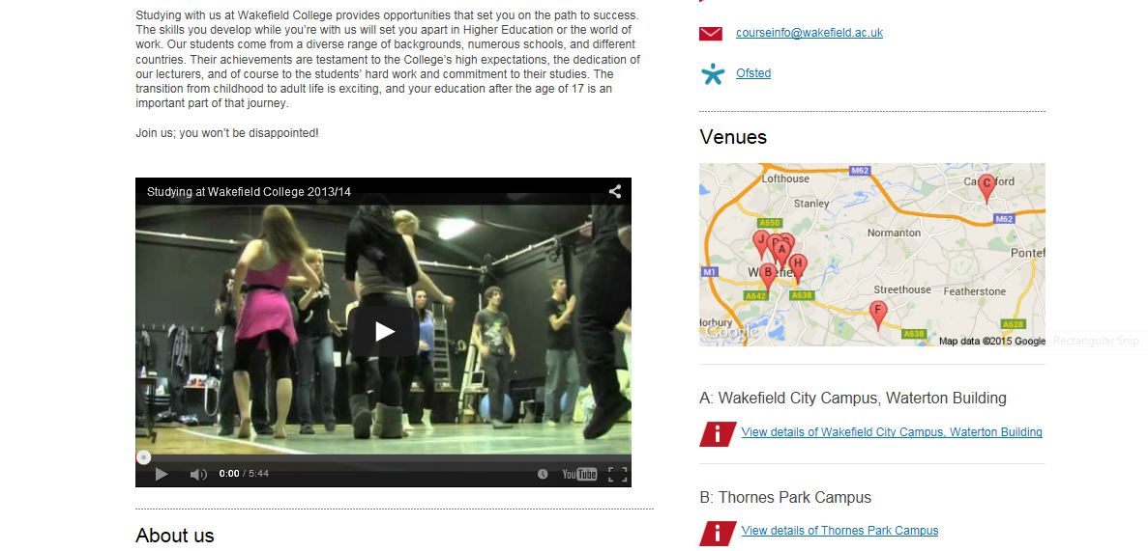

3. Extended Information

The following are free text boxes that can be edited and formatted using bold, italics, bullets and numbering. Links may be added and HTML can be utilised if required. Pictures can also be inserted to break up the text.

- Welcome Text
This is the first piece of information that will be viewed when clicking on the provider. This should be engaging and encourage the Year 11 student to want to read more. Providers should consider keeping this section brief and include images to break up the text.

- About Us
This section should be similar to the About Us section of a post-16 provider’s website. Providers could consider including the following:
- Brief history of the provider
- Summary of your provision, including the sectors and job types represented. Detail will be found within specific course information
- How your provision is delivered. For example, are your Apprenticeships delivered in the work place or delivered on day release at your training centre
- Quotes from learners
- Quotes from employers
- Existing Apprenticeship, Traineeship or work experience opportunities For example, large, well-known brands, overseas opportunities
- Emphasise how your provision adds value
- Include images of your organisation or your provision to break up the text

- Facilities Available
Use this section to highlight the facilities available at your establishment. This could include:
- Emphasise convenient location(s)
- Summary of venues and Transport Links to training centre(s) – detail is included in venue section
- Modern equipment e.g. classroom resources, training equipment, employer’s resources
- IT resources – free wifi, IT suites
- Catering
- Libraries
- Sports and Interests Groups/Clubs
- Employer Links

- Additional Support
Outline the support that you can offer, which could include:
- Additional learning Support for learners with any disability, medical condition, learning difficulties, where English is a second language
- CEIAG
- Enrichment Activities
- Counselling & Welfare Support
- Faith and Spiritual support
- Financial Support
- Health
- Learner Success
Consider including:
- Highlighting progression opportunities
- Real examples / case studies
- Statistics supporting progression opportunities
- Success in skills competitions
- Retention , achievement and overall success rates

Sections 4 and 5 are only relevant to schools and should not be completed by Post-16 providers.

4. Receiving Provider Information

If schools have uploaded student reference information, providers will automatically receive this.

5. “Before you apply” Information

Enabled by a tick box. Allows post-16 providers to offer potential applicants additional information prior to submitting the application/EOI. It could be utilised for:
- Timescales of acknowledgements
- Forthcoming Open Days
- Contact numbers for general information.

6. Venue Information

- Key information
- Name and address, mandatory
- Additional information
- Contact details
- Information about this venue – paragraph explaining where it is and the benefits of the location, when built, what’s contained there.

7. Logos

Post-16 providers can upload their logo from their provider manager screen. Valid file types are png, jpeg and gif files. The logo can have a maximum width and height of 192 pixels.

The logo will appear in the top right of the Provider Information section on the main website. Please see screenshot below:

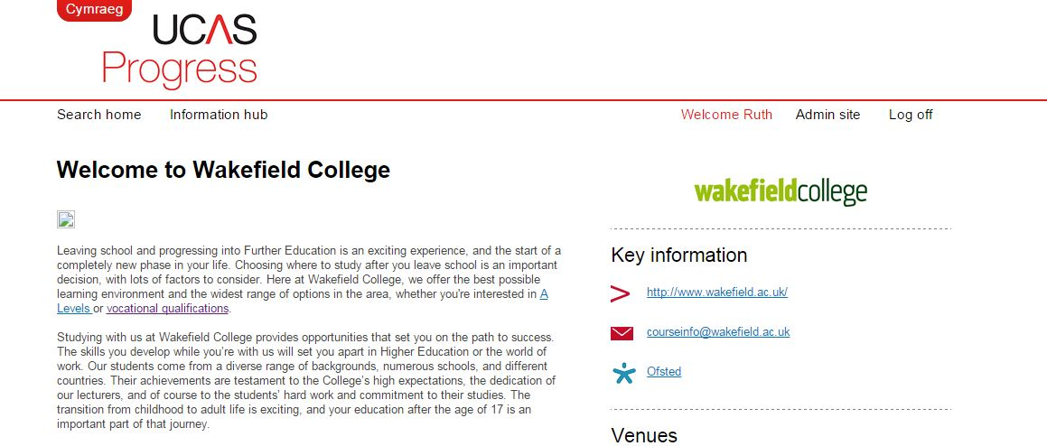

Section 3

Good Practice Guide in:
Uploading Excellent Course Information
Introduction:

What does this guide do?

This section of the guide has been produced to support post 16 providers to ensure that their course information is comprehensive, up to date and in a format that makes it both easy to find and engages the interest of young people using UCAS Progress.

Some fields are mandatory which automatically creates a minimum standard for uploading course information. However, this guide is intended to encourage post-16 providers to make the most of the optional fields by offering suggestions and recommendations for information that should be included to attract learners. This makes it much easier for young people to search for courses and understand the opportunities when displayed.

This guide follows the structure of UCAS Progress and the order of the fields which need to be populated for uploading course information into UCAS Progress.

1. Key Information

Mandatory fields are represented by *

- Title *
Name of the course to be included here. The following format should be used to facilitate the ease of searching for courses by subject in order for all qualification options are seen by the young person, parent/guardian or teacher for each subject area.

Hairdressing – Apprenticeship Level

German – A Level

Customer Service – BTEC Level 2

- Academic year *
This relates to the academic year for Year 11s making applications and Expressions of Interest (EOIs) rather than the calendar year. Please select the current academic year which you are entering the course for. The default will be for the current academic year.

- Courses for *
This is a mandatory field. Only select ‘For those who are looking at what to study after Year 11’

- Start date*
This field is mandatory. Select the option which is applicable to the particular course

- Visible *
This box must be ticked to enable courses to be searched. Your courses will not be visible to Year 11 learners unless this box is ticked.

- Course venues*
The must be selected where the course is being delivered and/or the venue which is offering the course. Venue is important for the Search function and a Manchester one is required for courses to be found by students searching within GM. Therefore

- Course type*
Check the box for the type of course you are loading

- Suitable for SEND
Please tick this box if your course is suitable for SEND.

- Description
This should be a brief overview of the course. If information is copied from other changes may be required to the formatting. For example adding in headers, paragraph breaks, bolding or italicising copy. Please see screenshot below which highlights what editing tools are available.

2. Additional Information

These fields are optional although it is strongly recommended that post-16 providers complete all fields. This information will help young people, parents and teachers to gain a better understanding of the courses being offered and help to inform a decision on whether to apply.

- Course contact
This is a drop down menu which is taken from the contacts which is held in the contact section for UCAS Progress. Contacts can be changed at any point by following the contact links in the Provider section. Screenshot below:

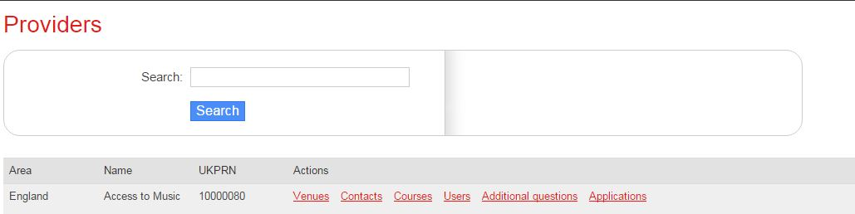

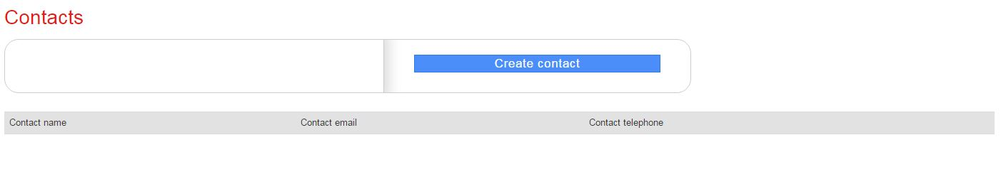
- Course code
Providers should include any internal codes which are used for course.

- Duration
The duration of a course should be entered to allow the young person to understand the commitment that is to be made when applying or making and Expression of Interest (EOI)

- Website
An opportunity for further information to be provided promoting the course and provider. The Course URL from a providers website should be entered here.

- Number of planned places
This can be used to detail if there are a limited number of places available. Or state that there is not a limit on places.

- YouTube video ID
Including a video about the course provides another opportunity to enhance the information provided about the course. This may help to bring it more to life for the young person and differentiate a provider’s course from others. It also helps the young person to gain a better understanding of the learning environment and what they might expect.

3. Extended Information

The following are free text boxes that can be edited and formatted using bold, italics, bullets and numbering. Links may be added and HTML can be utilised if required. Pictures can also be inserted to break up the text.

- Course Content
This is the section which leads after the course description so is the opportunity for the Provider to give a detailed overview of what the course entails. This can include:
- Any functional skills in English and maths
- Mandatory units
- Outline of the framework/course
- How the training is delivered i.e. classroom, on-the-job

- Entry requirements
This section should cover all the entry requirements including any required qualifications and grades. If providers have no entry requirements, this should be stated.

- Assessment
Use this section to include the following:
- Where the assessment takes place for vocational learning
- The type of assessment:
  - Continuous
  - Coursework
  - Exam/written
  - Portfolio of work
  - Online Assessment

- Financial information
This section should include the following details
- Confirmation that education and training is free for 16-18 year olds
- Any examination costs
- Cost for any purchase of equipment/books
- For Apprenticeships any details regarding salary if applicable (this is usually a statement regarding the minimum apprenticeship wage)
- What financial support is available and/or who to contact to find out more
- The impact on ‘in work’ and ‘out of work’ benefits for both young people and parents

- Future opportunities
This section allows Providers to demonstrate potential outcomes of the programme and what the opportunities for progression are. This enables the young person, parents and advisers to consider the opportunity in a broader context and to prompt them to consider medium and longer term goals. Examples of what to include might be:
- The next level of progression in terms of education and training
- Examples of careers which can be taken up after completing the course
- Case studies

- Further information
This final section is an opportunity for Providers to include any additional information, web links, contact details which they feel will further enhance the promotion of the course

4. Adding and removing qualifications

UCAS Progress allows Providers to add and remove qualifications.

Once you have saved the course an option will be added to the top of your course information screen. Please see screenshot below for an example:

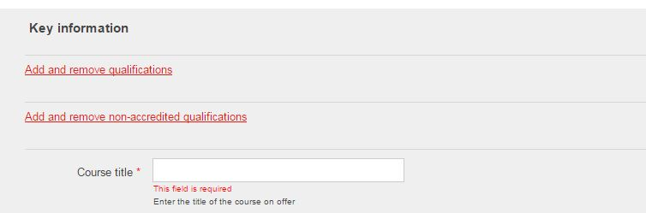

Follow the relevant link for accredited or non-accredited course. The following page will then appear and follow the instructions on the screen to add. To remove a course a delete button will appear under actions in the Qualifications assigned to course section. Please see screenshots below for accredited and non-accredited courses.

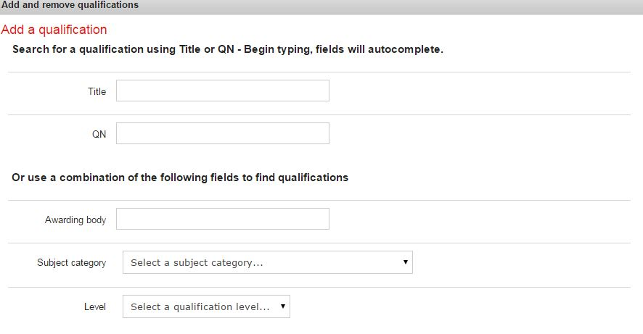

5. The course information screen on UCAS Progress Search

Below are some screenshots which detail what is seen when searched after the course information once a Provider has added a course. Therefore giving an example of what information can be included and how it si formatted.

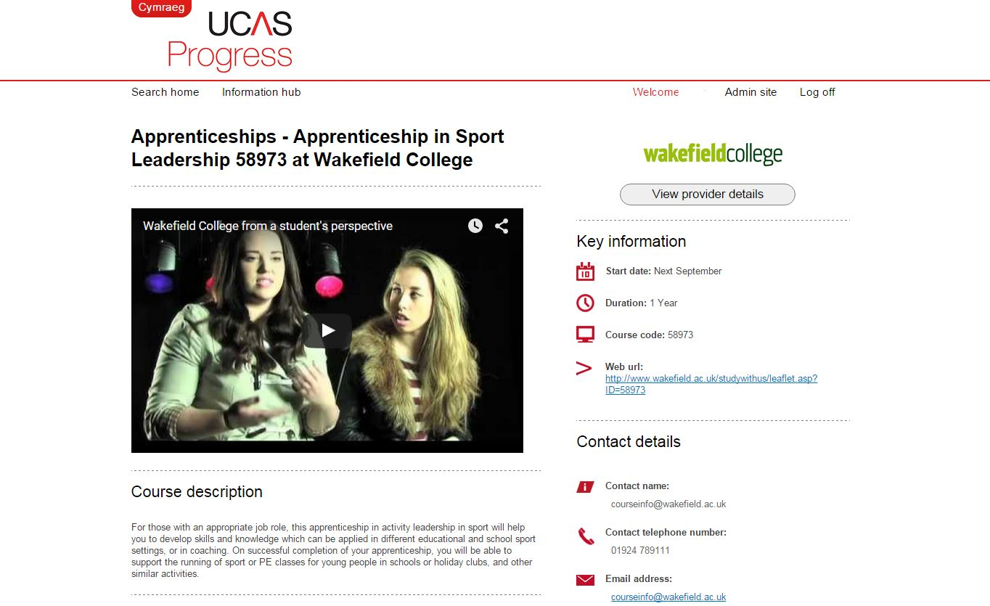

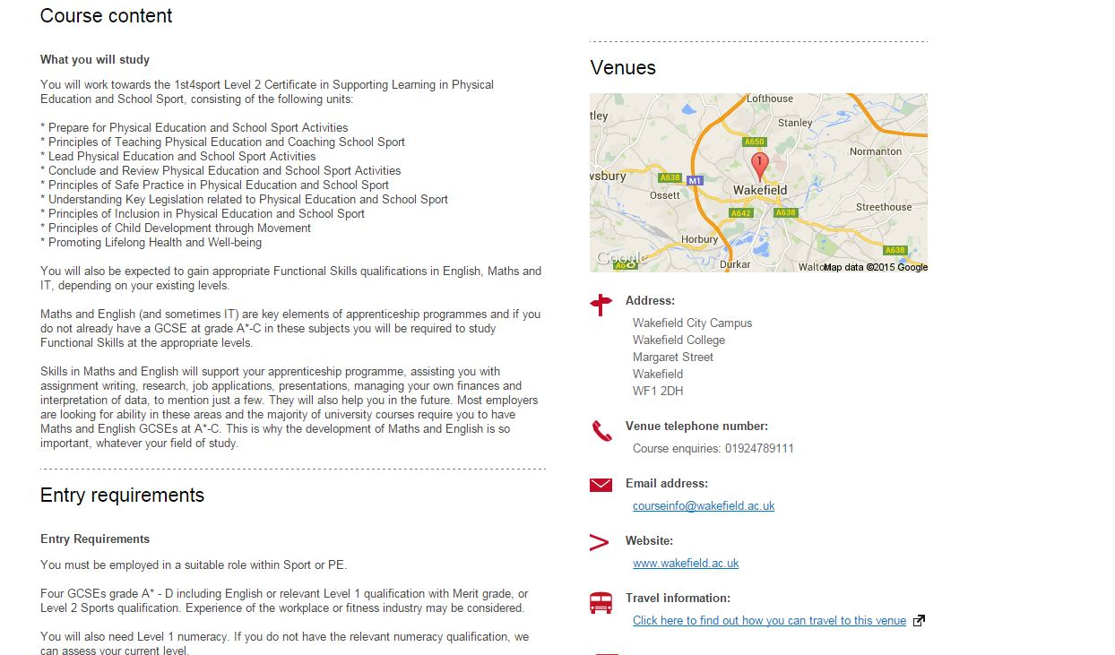

Section 4

Standards for:
Handling Apprenticeship Expressions of Interest

Introduction:

At present young people experience considerable variability in that individual Apprenticeship providers respond following the submission of an expression of interest in Apprenticeship opportunity.

By building upon existing good practice we aim to support providers to maximise the potential of the UCAS Progress system in supporting the recruitment of Apprentices and Trainees. We are also seeking to achieve a situation where young people can expect a minimum level of service. This is not about standardisation but is about capturing and disseminating the excellent practice which already exists both in relation to UCAS Progress and also to colleges and providers own recruitment and selection processes. By doing this we are seeking to improve the overall quality of the learner journey in respect of Apprenticeship and Traineeship recruitment.

Developing Good Practice and Defining Minimum Expectations:

Through a process of consultation with the Apprenticeship provider base we have identified good practice and are now encouraging Apprenticeship providers to commit to operating a set of minimum expectations when handling expressions of interest. This work has also been supported by a task group which comprises representatives of colleges and training providers.

By achieving widespread adoption of these minimum expectations we can guarantee a minimum level of service which young people can expect. This will in turn improve the overall standing of post 16 provision and Apprenticeships & Traineeships in particular.

Core Principles for Good Practice in Handling ‘Expressions of Interest’

The following core principles underpin the development of this good practice guide.
- Where course information, Apprenticeship and Traineeship opportunities are displayed on UCAS Progress the information should be:
  - Accurate
  - Up to date
  - Regularly reviewed to ensure that it remains accurate.

- Organisations posting post 16 and Apprenticeship/Traineeship opportunities in Greater Manchester should commit to accepting applications (‘Expressions of Interest’) via UCAS progress.

- Expressions of Interest for Apprenticeship opportunities submitted via UCAS Progress should be considered equally alongside applications submitted in other forms e.g. via AV or direct applications to the provider.

- Providers should establish early contact with young people who submit EOIs and should keep them informed as to the status of their application. They should undertake initial assessments as early as possible and where appropriate should ensure that young people are referred to additional information advice and guidance

- Where young people are not yet capable of making a successful Apprenticeship application they should be informed and directed to alternatives and to additional information, advice, guidance and support.

- Providers should keep UCAS Progress updated to support destination tracking.

A five Stage Process for

In developing our approach we have identified five key stages in the learner journey when young people are seeking to secure an Apprenticeship or Traineeship. The diagram below summarises the key stages and the following section of the guide sets out both minimum expectations and supplements this with examples of good practice.

A Five Stage approach for handling EOIs

Stage | Minimum expectations | Examples of good practice
STAGE 1  Young person submits  EOI via UCAS Progress  Receipt of EOI in the autumn term from a year 11 | Apprenticeship & Traineeship providers should:  - have in place a process for checking UCAS Progress for EOIs on a regular basis  - ensure that they have a named individual(s) with this responsibility and ensure that they monitor that UCAS Progress is being accessed on a regular (daily) basis to monitor EOIs  - acknowledge the receipt of the EOI via the UCAS system with 3 days working days  - the EOI should be treated as an ‘application’ and the provider should inform the young person, within three days, setting out the key stages of the recruitment process and the immediate next steps t  - provide the young person with a named contact and contact details and ensure that that contact is made with the young person. | The UCAS Progress System is checked on a daily basis.  Allocation to a named individual to act as first point of contact who ensure that acknowledgements are sent to the young person.  YP key informed via newsletters, social media and texts/e-mail alerts.  Obtaining the details of the YPs personal e-mail, address and mobile numbers to ensure continued contact and wider communications  Capturing details of parents and carers to engage them in the EOI process at an early stage.  Having in place a system of regular communications and updates  Feedback to schools that they have received EOIs by updating the UCAS Progress system
Stage 2  Engagement and Initial Assessment  (Autumn term)  Or within 8 weeks of receipt of an EOI | Within 8 weeks an Apprenticeship/Traineeship provider should:  - Meet with the young person and undertaken an initial assessment including an assessment of the young person’s readiness to undertake an Apprenticeship  - Inform the young person of the outcome of the assessment and advise them accordingly  - Ensure that where the initial assessment indicates that the young person is not yet ready for the Apprenticeship opportunity they should be directed to additional IAG  - Provide feedback to the school preferably via UCAS Progress  Wherever possible providers are recommended to hold face to face meetings (potentially in groups) during the autumn term. | Introductory meetings between the young person and the skills provider soon after applications are submitted or a group of young people if multiple applications received from one school.  Information provided which sets out the application and recruitment process and will include what will happen and when. Provision of information setting out the additional information advice and support which can be provided  Explaining to young people:  - If there are additional assessment requirements / interview.  - Young people made aware if they are likely to meet the required ‘standard’ based on predicted GCSEs/initial assessment  - Young people directed to additional advice, guidance and support
Stage 3  Encouraging and supporting young people to make applications | Apprenticeship providers should explain to young people:  - The types and volumes of Apprenticeship vacancies which are likely to arise and when these opportunities will become available and the next steps in the application process.  - Any GCSE (or other qualification) grades and additional requirements (references)  - How the young person will be kept informed and how and when they will be made aware of specific opportunities. (If this is done via UCAS it depends on the young person accessing the system – additional contact details?)  - What the young person needs to do in order to submit their application to a specific vacancy(s) and how these will be handled so that young people and their parents understand the timescales  - Communicate Any qualification requirements/minimum qualifications  Additional information required /personal statements/references/work experience etc | Involving parents at an early stage, obtaining details and ensuring they are aware of the status of the EOI and follow up.  Have in place a clear strategy and mechanisms for maintaining contact with young people, schools, parent.  Examples of good practice  - School liaison staff  - Invitation to open days  - Opportunity to meet with Apprentices (buddying)  - Opportunity to meet with an employer  - Mock interviews  - Utilising Apprenticeship week to host provider visits to showcase opportunities  - Have a Go type opportunities  - Mentoring
Stage 4  Applications to Apprenticeship vacancies | Recommendation  Providers should keep young people informed as to the status of their ‘applications’ to specific vacancies and to:  - Provide feedback within 1 week of the outcome of their application/interview  - Have in place mechanisms for updating UCAS and to provide feedback to schools as to the outcome of applications  - If unsuccessful providers should feedback to young people on the outcome of the application and to advise them of alternative opportunities and where appropriate to direct them to additional advice and guidance.
STAGE 5  Recruitment | Recommendation  At the point that the young person commences their Apprenticeship the UCAS Progress system should be updated and set to ‘enrolled’.  This will enable LAs and schools to track destinations and to monitor the overall impact of the effectiveness of CEIAG, the management of transition the RPA strategy including the reduction of NEETs and ‘unknowns’. | Skills providers have a process in place for updating UCAS Progress and communicating to schools the outcome of the recruitment process.

